**1**

**Template**

## Define your problem statement

**Before you collaborate**

A little bit of preparation goes a long way with this session. Here’s what you need to do to get going.

**10 minutes**

What problem are you trying to solve? Frame your problem as a How Might We statement. This will be the focus of your brainstorm.

**5 minutes**



**2**

## Brainstorm

Write down any ideas that come to mind that address your problem statement.

**10 minutes**

User registration.

### Shajitha..

An donor should be eligilbe or not for donate

An register donor will anly able to donate.

**C Learn how to use the facilitation tools**

Use the Facilitation Superpowers to run a happy and productive session.

[**Open article**](https://support.mural.co/en/articles/2113740-facilitation-superpowers)

The donors history of donation.

**Biruntha..**

**TIP**

You can select a sticky note and hit the pencil [switch to sketch] icon to start drawing!

TECHNICAL IMPLEMENTATION.

**A Team gathering**

Define who should participate in the session and send an invite. Share relevant information or pre-work ahead.

Live location of donor.

**TIP**

Add customizable tags to sticky notes to make it easier to find, browse, organize, and categorize important ideas as themes within your mural.

# To keep Donor engaged.

Donation reward.

**4**

**Prioritize**

**3**

**Group ideas**

Take turns sharing your ideas while clustering similar or related notes as you go. Once all sticky notes have been grouped, give each cluster a sentence-like label. If a cluster is bigger than six sticky notes, try and see if you and break it up into smaller sub-groups.

**20 minutes**

Your team should all be on the same page about what's important moving forward. Place your ideas on this grid to determine which ideas are important and which are feasible.

**20 minutes**

**Brainstorm**

**& idea prioritization**

Use this template in your own brainstorming sessions so your team can unleash their imagination and start shaping concepts even if you're not sitting in the same room.

Provide a virtual card.

Make an appointment for donation.

## After you collaborate

You can export the mural as an image or pdf to share with members of your company who might find it helpful.

### Quick add-ons

1. **Share the mural**

**Share a view link** to the mural with stakeholders to keep them in the loop about the outcomes of the session.

PLSAMA DONOR APPLICATION.

1. **Export the mural**

Export a copy of the mural as a PNG or PDF to attach to emails, include in slides, or save in your drive.

history of donation.

# 

**10 minutes** to prepare

**1 hour** to collaborate

**2-8 people** recommended

Collobrate with local blood banks.

### Key rules of brainstorming

To run an smooth and productive session

### Keep moving forward

**Strategy blueprint**

**B Set the goal**

Think about the problem you'll be focusing on solving in the brainstorming session.

Define the components of a new idea or strategy.

[**Open the template**](https://app.mural.co/template/e95f612a-f72a-4772-bc48-545aaa04e0c9/984865a6-0a96-4472-a48d-47639307b3ca)

When donation process do's or don't

**Customer experience journey map**

Location based donor available.

Stay in topic. Defer judgment.

Hospitals treatment

Location based donor matching.

Encourage wild ideas. Listen to others.

### Importance

Constant appointment updates.

Acknowledgement process

If each of these

Understand customer needs, motivations, and obstacles for an experience.

[**Open the template**](https://app.mural.co/template/b7114010-3a67-4d63-a51d-6f2cedc9633f/c1b465ab-57af-4624-8faf-ebb312edc0eb)

24/7

servces.

Previous donor debits

Go for volume. If possible, be visual.

PLASMA DONOR APPLICATION.

### Poomitha..

Safety measures

User friendly interface

**Pavithra..**

Donor can modify the profile

# Hospitals.

Plasma bank.

Safety measures.

User testimonals

Verification of user provide details.

Methods.

tasks could get

done without any difficulty or cost, which would have the most positive impact?

**TIP**

Participants can use their cursors to point at where sticky notes should go on the grid. The facilitator can confirm the spot by using the laser pointer holding the **H key** on the keyboard.

**Strengths, weaknesses, opportunities & threats**

Identify strengths, weaknesses, opportunities, and threats (SWOT) to develop a plan.

Safety measures.

|  |  |
| --- | --- |
|  |  |
|  |  |

[**Open the template**](https://app.mural.co/template/6a062671-89ee-4b76-9409-2603d8b098be/ca270343-1d54-4952-9d8c-fbc303ffd0f2)

[**Share template feedback**](https://muralco.typeform.com/to/CiqaHVat?typeform-source=app.mural.co)

Create awarness.

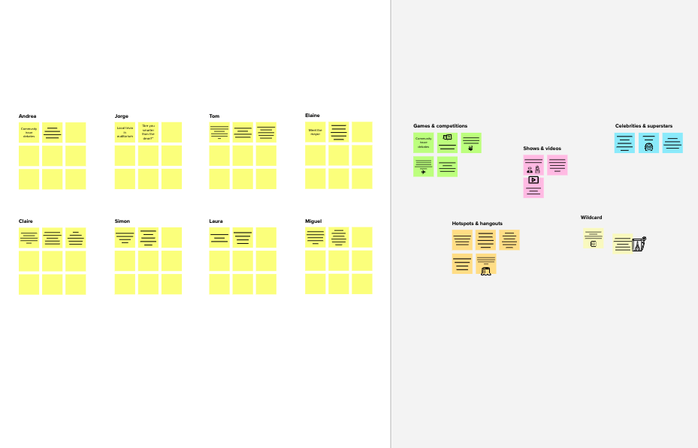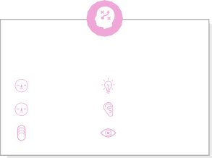

FAQ section for donor's

Communication between donor and seller

Verification of donor details.

Donation awarness program.

Donation camp.

Make a donor appointment.

Real time details of available donor.

Provide a virtual donor cardfor donor.

Sending the direct request for an plasma donor.

Live location of donor.

### Feasibility

[**Share template feedback**](https://muralco.typeform.com/to/CiqaHVat?typeform-source=app.mural.co)

Provide treatments.

Regardless of their importance, which tasks are more feasible than others? (Cost, time, effort, complexity, etc.)

**Need some inspiration?**

See a finished version of this template to kickstart your work.

[**Open example**](https://app.mural.co/template/e5a93b7b-49f2-48c9-afd7-a635d860eba6/93f1b98d-b2d2-4695-8e85-7e9c0d2fd9b9)